## **Oxford Triathlon Club - Open Water Swimming**

## **Swim Supervision Guidelines**

**Introduction**

The following guidelines are intended to improve the safety of participants taking part in our open water swim sessions and to comply with the requirements of the site owner.

Each OxfordTri open-water swim session is to be supervised by a minimum of two Lake Safety Personnel.

The first Lake Safety Officer remains at the lakeside for the duration of the open water swim session, at a point that they can view all swimmers in the water (standing at the end of the left pontoon is recommended), as well as those entering and leaving the water.

The on-water Lake Safety Officer/s assists with the initial stages of the session and then monitors swimmers from on the lake via a Kayak or SUP. N.B. The on-water Lake Safety Officer/s are required to wear a suitable life jacket.

If there are only two Lake Safety Officers, then participants are only permitted to swim the smaller 500m loop.

If there is an additional on water Lake Safety Officer, the safety team agree, and the conditions permit, then the 750m loop is able to be opened.

**Safety Team to consider before starting session**

**Weather & Environment**

What are the prevailing weather conditions for the upcoming swim session, and what is the water temperature and water conditions i.e. wind, waves or weed.

If there is a Red warning for wind, rain or thunder and lightning at the time of the planned swim session then the session will be cancelled by contacting the [committee@oxfordtri.co.uk](mailto:committee@oxfordtri.co.uk) email or whatsapp to a committee member.

If there is an Amber warning for rain, wind or thunder and lightning then the session may go ahead subject to the timing of the warning. If the warning coincides with the planned swim session, then full consideration should be given as to whether the session can proceed. If in any doubt the session should be cancelled by contacting the [committee@oxfordtri.co.uk](mailto:committee@oxfordtri.co.uk) email or whatsapp to a committee member.

If there is a Yellow warning for rain, wind or thunder and lightning then consideration should be given for the time of the warning and how the weather may affect the swim session. If in any doubt, contact the [committee@oxfordtri.co.uk](mailto:committee@oxfordtri.co.uk) email or whatsapp to a committee member for support and advise.

If thunder and lightning is seen during the session the swim must be suspended immediately, all swimmers and the on-water Lake Safety Officer must exit the water as soon as possible. The session will not restart until 30 minutes has passed since thunder/lightning being seen/heard. If the thunder and lightning has been considered past by the Lake Safety Officers and they consider it safe to do so then the swim session can restart.

N.B. Sound travels at 330 m/s so each second between the flash of lightning and the thunder means the lightning strike is 330 metres away, so 3 seconds means that the lightning strike is less than a kilometre away.

**Number and experience of swimmers**

Review the number of swimmers signed up via the website, and ensure that swimmers are able to swim 400m, as this is a requirement for our open water sessions.

If a swimmer has not swum open before they should be buddied up with an experienced swimmer for their first lap. If the buddy and the land Lake Safety Officer feel that they are competent to swim alone then they may continue swimming. If they are not considered competent then a buddy should continue to swim with them, if one is available, otherwise they will be required to exit the water.

**Water Hazards**

The Safety Officers need to consider if there are other lake users on the day and what hazard they may pose. Also, if waterfowl are nesting near to our swim course and whether they may pose an additional risk that may need consideration.

**General**

**Priorities:**

The first and overriding priority of the Lake Safety Officers is to supervise the swimmers in the water and to raise the alarm in the event of an emergency.

1. **Tow Floats** and **Bright Swim Caps** must be worn by all swimmers.
2. We observe BTF guidelines, with regards to the wearing of **Wetsuits** this means that we advise that swimmers use wetsuits when the water temperature is below 14 degrees Celsius. When the water temperature is above 24.6 degrees Celsius wetsuits should be worn with caution to minimise the potential for overheating, with shorter swimming time and regular flushing of their wetsuit.
3. Each Lake Safety Officer should have a mobile phone with signal and/or 2 Way Radio with them with sufficient charge to use in the event of any emergency.
4. Open-water swim sessions are strictly for OxfordTri members or invited guests (Guests - on certain dates agreed by the committee in advance). Joining the Club includes completing the disclaimer for open-water swimming. Guests however should complete our club disclaimer prior to entering the water if it is their first-time swimming at a club run session.

### **Before the Swim Session**

1. It is advised that those who are covering Lake Safety for the session arrive a minimum of 15 minutes early to collect the equipment.
2. Within the Water Sports Pavilion (see map) we store our box which contains everything apart from the kayak. This can be accessed by entering the pavilion and then entering the room which is behind the desk. Our box is located on the top shelf and will have around or on-top of it; the kayak paddle (in two parts), 1x Kayak Seat, 2x Torpedo Buoys, 1 x Blackboard and 1 x Whiteboard. N.B. If you are unable to find the paddle, please select one of the paddles next to the non-club kayaks. (if the pavilion is locked – the kit will be in the wooden shed next to the pavilion).
3. The club kayak is a plain yellow one and can be found on the external shelving on the back of a hut next to the end pier (see map). Lifting it and taking it down to the water is best done between two people as it is quite heavy to lift on your own. 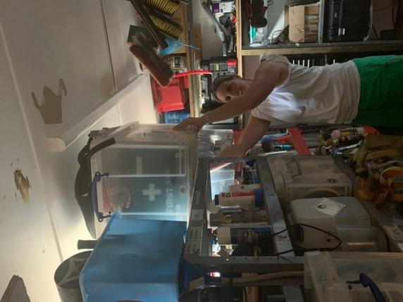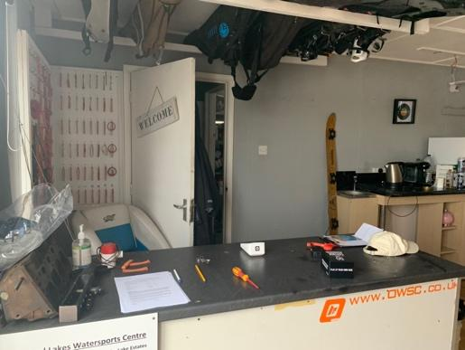

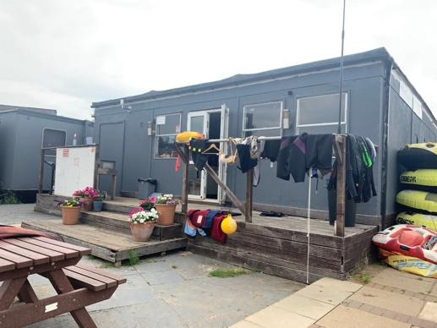

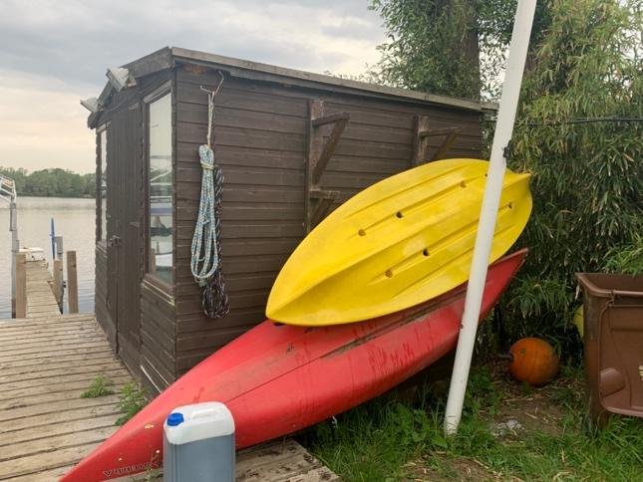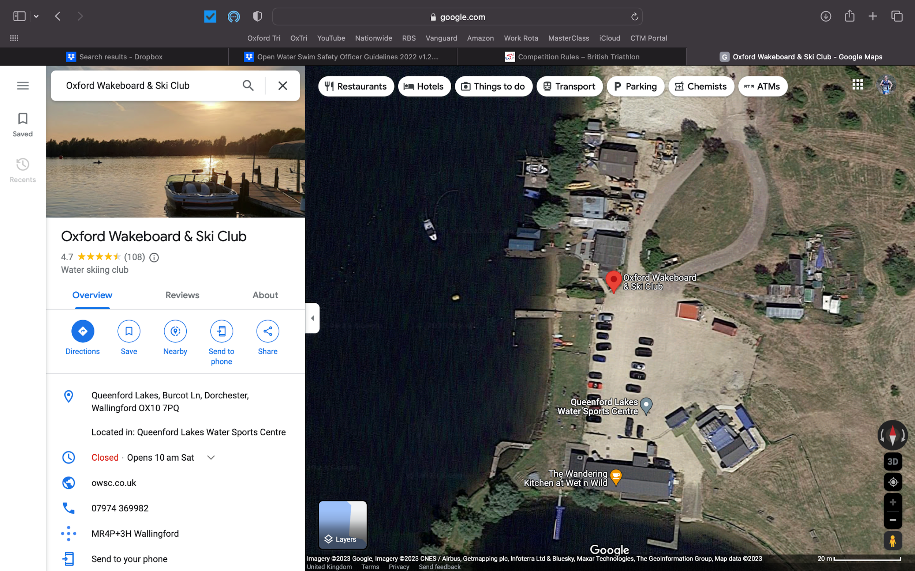

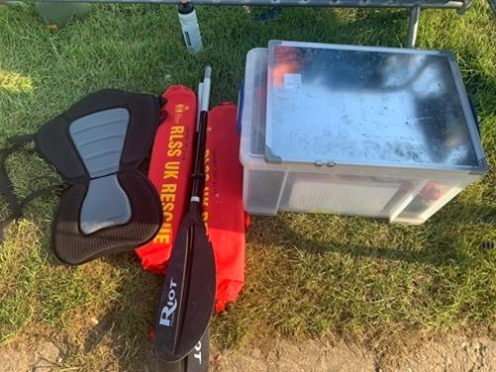

**The Lake Safety Officers should**:

1. Check the contents of the Safety Box
2. Measure the temperature of the lake. Temperature restrictions are listed below.
3. Assess whether there are any additional hazards on the day that make the planned session unsafe. Examples of factors to take into consideration are listed at the end of these guidelines. It is the Supervision Personnel decision as to whether a session proceeds as planned, is altered or is cancelled.
4. Wear a high-visibility vest (from the Safety Box), to help identify the land-based Lake Safety Officer. It is also advised that they wear a life jacket, provided by the club, should they need to aid with any rescue scenario.
5. Set up the blackboard (preferably) or the whiteboard, so it is ready for participants to sign in and out.
6. A pre-swim safety briefing is mandatory for all participants this should take place at the time the session is due to start.
7. Before the swimmers enter the water, Supervision Personnel should:
   1. Make sure that all swimmers are assembled, can hear and are paying attention.
   2. Read the safety briefing below.

**Swim Safety Briefing**

Welcome to the lake. We hope you have a great swim. Please be aware of the following information and a few rules to keep you and your fellow swimmers safe in the water.

1. We have checked the weather forecast and assessed that the session can go ahead, however in the event of sudden high winds or rain, athletes must listen out for the airhorn suspending the session. If lightning is seen, or thunder is close by, the air horn will be sounded, and swimmers should exit the water promptly and safely at the nearest point.
2. We have assessed other hazards at the lake (communicate what these hazards are and what to do about them e.g. don’t swim into swans with cygnets or look out for boats)
3. The lake temperate is……and the available loops are………..
4. Assuming the water temperature is above 14 degrees and below 24.6 wetsuits are optional (If the water temperature is outside these limits, please refer to this document for additional guidance under **General** note 2).
5. Tow floats are mandatory
6. Bright hats are mandatory
7. You must be a member and have signed up on the website for OxfordTri or on Spond for members of Wallingford Triathlon Club (When they are swimming with us, Wednesday only)
8. You must have signed in with your full name on the blackboard/whiteboard, selected a **Red band for OxfordTri** and **Blue band for Wallingford** and recorded the band number next to your name.
9. Explain the swim course available on the day, the course available will be dependent on the number of on water Lake Safety Officers, the weather, lake conditions and the decision of the Lake Safety Officers.
10. If you have a medical condition, or an injury that may impact you while swimming please talk to us after the briefing (note condition and what medication you need to keep available, along with their name and their wristband number)
11. Please be considerate of others, try not to swim over or into people causing distress, if you see a swimmer holding their float please check they are ok before swimming on. If they need assistance, attract the Lake Safety Officer’s attention with a whistle, shout and wave. Assist the swimmer if you feel that you are able, though please do not put yourself in danger, especially if the swimmer is panicking as they may grab you, so please keep a safe distance.
12. Ask if there are any qualified First Aiders or rescue trained swimmers today, who may be able to assist in the event of an emergency?
13. In the event of an emergency the Lake Safety Officers will sound an air horn or repeatedly whistle to indicate there is an emergency. If you hear the air horn sounding, please assess if you can help with the situation before returning to the shore.
14. Access to the water is via the beach area in front of the pavilion, do not use the slipway to get in or out of the water as it is very slippery.
15. Please sign out by removing your name from the sign in-board being used and return your wristband before leaving the lake.
16. If the swimmer is new to open water swimming, then they need to be buddied up with an experienced swimmer, for a lap, or part of, to evaluate their competence. If the buddy considers them competent then they can continue swimming on their own.
17. Ask if anyone has any additional questions or need clarity on any points.

N.B. If swimmers arrive late, after the briefing has taken place, they must report to the land-based Lake Safety Officer to confirm they are signed up on our website for the session or via Spond if it is a Wallingford member. The land-based Lake Safety Officer will deliver the Safety Briefing to ensure they are aware of key information.

### **The Swim Session**

1. Once the brief is completed, allow the swimmers who are not novices/new to the club to enter the water via the beach area in front of the waterski pavilion not the slipway which is unsafe.
2. Check whether swimmers new to the club have any questions about any aspects of the swim. If not, allow them to enter the water.
3. Novice open-water swimmers must initially be paired with a competent swimmer and complete a small lap
4. It is important that the Land Safety Officer ensure that swimmers record their full name and wrist band number on the club blackboard or whiteboard whichever is being used for the Open Water Session and that the member has signed up for the session on the club website.
5. While swimmers are in the water, the land-based Lake Safety Officer/s and water-based Lake Safety Officer should regularly scan the water, binoculars are provided, if required, and occasionally check two-way radios are working.
6. Late arrivals who missed the briefing must contact the land-based Lake Safety Officer to check the key briefing details, confirm sign up and sign in procedures completed before entering the lake.

### After the Session

1. At the end of the session or once all swimmers are all believed clear of the water, double-check that there are no names left on the board and no swimmers can be seen in the lake.
2. Return the Safety Box, with the Kayak Seat, White Board, Blackboard and two Torpedo Buoys to the pavilion (or wooden shed of the pavilion is locked) and return the kayak to the shelving, and paddle to where you found it.

### **What To Do If Something Goes Wrong**

**Emergency Action Plan**

1. If you notice a swimmer or swimmers in trouble,
2. Firstly, the on-water Laker Safety Officer/s should approach the swimmer in trouble to assess the situation.
3. Communicate with the land-based Lake Safety Officer to update them on the situation. Be aware not to put yourself in danger,
4. If a swimmer is panicking, don't let them grab you or climb on your kayak or SUP as this may put you at risk. Talk to them calmly, encouraging them to make use of their tow float and to take deep breaths to help relax.
5. If the swimmer is relaxed but tired and needs support, encourage them to hold onto your board or kayak while you plan how to help them get to shore.
6. If the swimmer is unconscious make sure they are rolled onto their back to avoid water ingestion and enlist help from other swimmers to get the casualty to shore, get first aid help and contact the emergency services immediately.
7. If the safety officers believe the session needs to be cancelled to deal with a casualty, sound the air horn repeatedly and contact the relevant supervision member via the two-way radio. Swimmers should exit the lake at the usual swimmer entry/exit point.
8. Monitor the return of the swimmer(s) in trouble. If they appear unconscious and are being dragged back by fellow swimmers, phone 999 immediately and ask for an ambulance giving the following information:
9. **Location:**

**Address**: Queenford Lake, Burcot Lane, Berinsfield, OX10 7PQ.

**What3words**: Shoulders.thus.gong

1. **Incident**: Something has happened to (giving the number of swimmers in trouble), while they were swimming in the lake, they appear to be unconscious, possible drowning.
2. Current location of swimmer(s) in trouble (eg, still in lake, on the lakeside).
3. Any other relevant information.
4. If the person is apparently conscious but is being dragged or escorted back to the side, wait to call the ambulance until they are out of the water and assess their condition. **If you are in any doubt at all, call an ambulance using a modification of the list of information above.**
5. As other swimmers arrive and get out of the lake, keep them clear of the immediate area and tell them to keep warm, getting changed if necessary. (Cases of hypothermia will only complicate matters) Check whether there is a qualified first-aider present (we should do this in the briefing); if there is then we should ask them to assist with the person in distress. Use other swimmers to assist if required.
6. 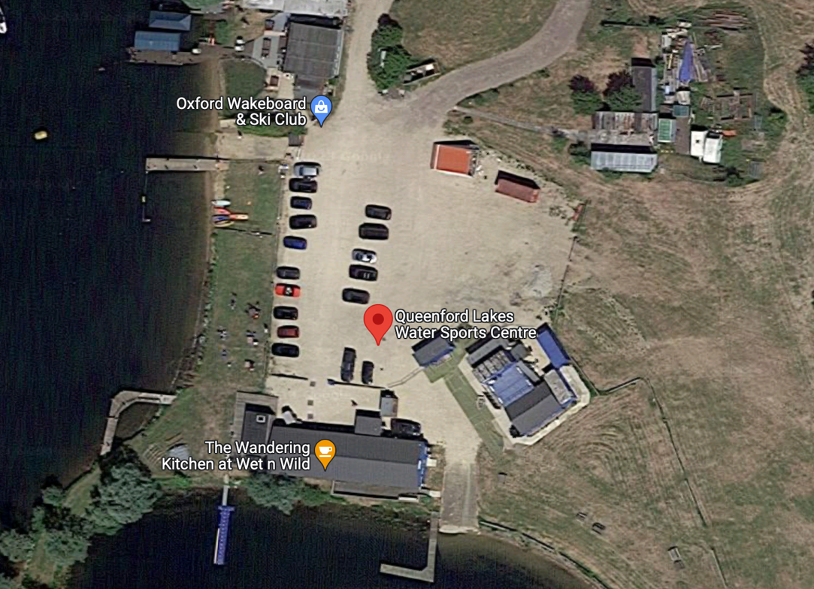Defibrillator – If needed this can be found on the far side of the Wandering Cafe building towards the Wet and Wild Lake (See Map). Please follow the instructions on outer case, you will need to call 999 to request the code to access the defibrillator. 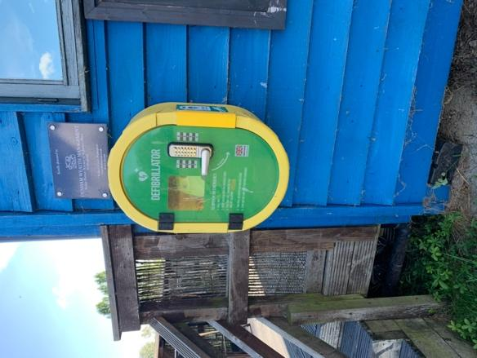

Swim Exit/Entrance

Defibrillator

## **Hazards**

1. The risks associated with swimming in Queenford Lake have been assessed and it has been concluded that it is safe for swimming in normal circumstances.
2. Abnormal circumstances may make the lake temporarily unsafe for swimming. Examples of abnormal circumstances are listed below. If any of these are present, the session is to be cancelled until these no longer apply. If in any doubt, remember that your first and overriding priority is the safety of the swimmers and cancel the session.

**Fog or mist**

If swimmers 10 metres past the furthest end of the day’s route could not be clearly seen. This might be overcome by shortening the route. If conditions change during the session, sound the hooter, recall all the swimmers, re-brief them as to the new route, let the session continue and monitor the conditions closely.

**Wind that generates waves**

If swimmers 10 metres past the furthest end of the day’s route could not be clearly seen. This might be overcome by shortening the route. If conditions change during the session, sound the hooter, recall all the swimmers, re-brief them as to the new route, let the session continue and monitor the conditions closely. If in any doubt, remember that your first and overriding priority is the safety of the swimmers and cancel the session.

**Thunder & Lightning**

If the Safety team can see lightning, or they can hear thunder very close by, the session should be stopped immediately via sounding the horn with swimmers being advised to exit the lake at the nearest point. Swimmers may be permitted to re-enter the lake after a period of 30 minutes where there has been no lightning or thunder, if the Lake Safety Officers consider it safe to do so. The 30-minute clock must be restarted after every sighting of lightning or thunder heard.

**Blue-Green Algae (BGA).**

Algal bloom of one variety or another is a common phenomenon in the lakes and rivers of lowland Britain during mid-summer and early autumn. The main danger to swimmers is from high concentrations of decaying bloom which has a distinct blue-green colour. The signs of this are unpleasant odours and the appearance of scum on water and the lake shore. Contact with toxic scum can cause skin diseases and eye irritation, swallowing it, or more serious illness.

N.B.Queenford Lake’s water is constantly monitored and treated to prevent harmful algae blooms, if algae becomes a potential hazard OxfordTri will be advised and if necessary, the lake will be closed to swimmers.

## **SAFETY BOX CONTENTS**

Air-horn and spare gas cylinder - we have whistles in case the horn malfunctions

First Aid Kit

4 x waterproof Two-Way Radios (plus 4 non-waterproof battery two-way radios)

Binoculars (compact, in leatherette case)

High-visibility vests

Copies of Safety Officer Guidance and Safety Briefing Instructions

White Board Marker Pens

Blackboard Marker Pens

Spare Swim Caps

Spare Tow Floats