### **OxfordTri - 2025**

### **Emergency Action Plan**

1. If you notice a swimmer or swimmers in trouble,
2. Firstly, the on-water Laker Safety Officer/s should approach the swimmer/s in trouble to assess the situation.
3. Communicate with the land-based Lake Safety Officer to update them on the situation. Be aware not to put yourself in danger,
4. If a swimmer is panicking, don't let them grab you or climb on your kayak or SUP as this may put you at risk. Talk to them calmly, encouraging them to make use of their tow float and to take deep breaths to help relax.
5. If the swimmer is relaxed but tired and needs support, encourage them to hold onto your board or kayak while you plan how to help them get to shore.
6. If the swimmer is unconscious make sure they are rolled onto their back to avoid water ingestion and enlist help from other swimmers to get the casualty to shore, get first aid help and contact the emergency services immediately.
7. If the safety officers believe the session needs to be cancelled to deal with a casualty, sound the air horn repeatedly and contact the relevant supervision member via the two-way radio. Swimmers should exit the lake at the usual swimmer entry/exit point.
8. Monitor the return of the swimmer(s) in trouble. If they appear unconscious and are being dragged back by fellow swimmers, phone 999 immediately and ask for an ambulance giving the following information:
9. **Location:**

**Address**: Queenford Lake, Burcot Lane, Berinsfield, OX10 7PQ.

**What3words**: shoulders.thus.gong

1. **Incident**: Something has happened to (giving the number of swimmers in trouble), while they were swimming in the lake, they appear to be unconscious, possible drowning.
2. Current location of swimmer(s) in trouble (eg, still in lake, on the lakeside).
3. Any other relevant information.
4. If the person is apparently conscious but is being dragged or escorted back to the side, wait to call the ambulance until they are out of the water and assess their condition. **If you are in any doubt at all, call an ambulance using a modification of the list of information above.**
5. As other swimmers arrive and get out of the lake, keep them clear of the immediate area and tell them to keep warm, getting changed if necessary. (Cases of hypothermia will only complicate matters) Check whether there is a qualified first-aider present (we should do this in the briefing); if there is then we should ask them to assist with the person in distress. Use other swimmers to assist if required.
6. 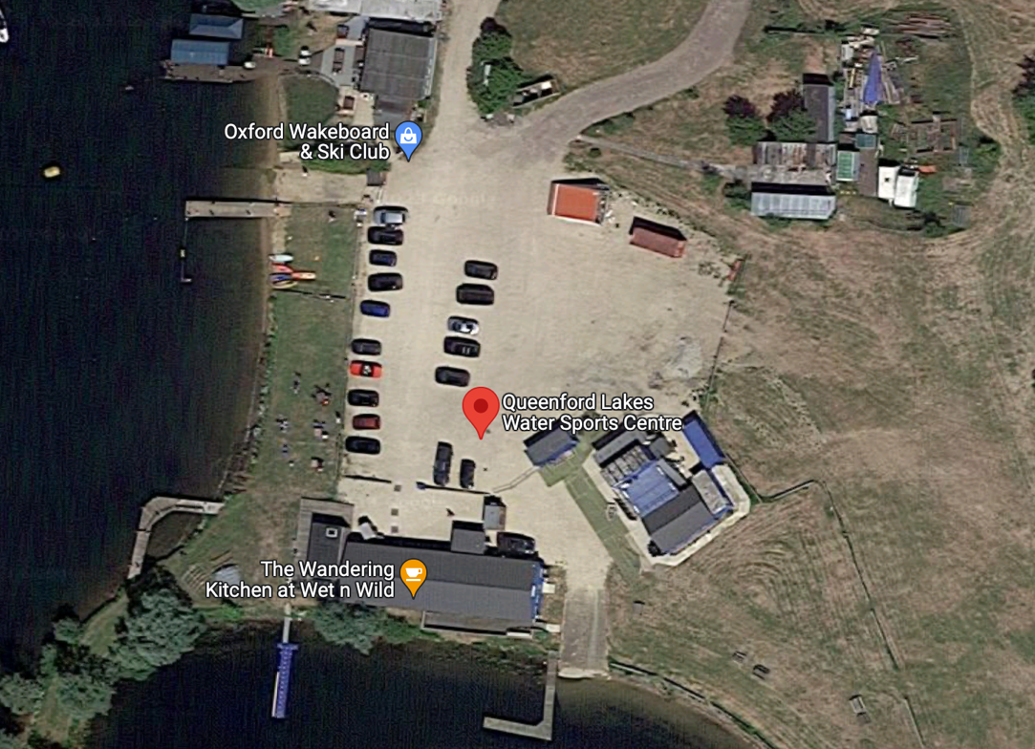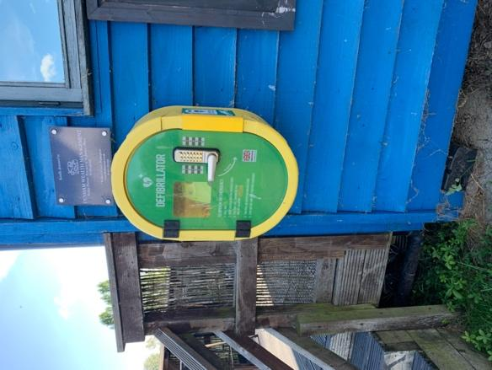Defibrillator – If needed this can be found on the far side of the Wandering Cafe building towards the Wet and Wild Lake (See Map)

Defibrillator

Swim Exit/Entrance