AGM 2023 Oxford Tri Club 19th of October 2023 19:00 Oxsrad

30 in person and 3 online - numbers attending means meeting was quorate

Craig Welcome

Apologies for technical issues

Apologies: Liam and Leftaris

2022 Minutes - Kelly and Lee approved

Chairman's report (Craig):

- Highlights 1. Cross country (thank you Kelly) - good place to build relationships, ladies did well 2. Sessions developing and grow (moving sessions closer to Oxford/local community developing) 3. Introducing member of the month (opportunity to thank people and recognise people's efforts) 4. Create a strategy as a committee 5. Open water swims (great number of people) 6. Developed a relationship with Limelight sport and helped bring new faces into the club (promoting OWS) 7. Achievers in the club at world athlete levels and a lot more people racing in club gear around events
- Challenges 1. Limited volunteers despite the large pool of members 2. Transactional members and people not as involved as a community stye/feel - how to create that kind of culture moving forward (affordable cost of membership, currently working at a loss)
- Working on it 1. Membership structure (comes up frequently - we are hearing people's opinions and trying to put something together and will share what it will look like and can decide how to progress accordingly. 2. EDI - we would like to develop a few things as a club and working on it (possibly could create a role, if people are passionate about this please come and speak to us and discuss how we can move forward)
- Reflections 1. Strategic priorities:
  - Opportunity - brought sessions close to Oxford, working on improving group rides, awareness on improving communication and social media aspects of the club - making the right steps in the direction, wanted to organize an event for the club (Radley Tri, swim/bike/run event, OTC training camp/training day) will work on it for 2024 - more of smaller events such as the cheesy duathlon
  - Coaching - had a number of people who have qualified as level 2 coaches, financially supporting coaches, want to improve the development of coaches
  - Community - Oxford tri community - increased the number of social events in the calendar, still working on improving the sense of community in the club and with the whole overall Oxford community - give back to local sport - have had various volunteers this year for Oxford Half and Blenheim, looking to partner with local business and clubs (Wallingford joined forces with the OWS) - help share financial resources and meet new people and support local communities
  - Sustainability - actively increase members, working on our environmental (tried car share), increase the number of members in voluntary roles in the community
- Group brainstorming sessions (5min to discuss and 5 minutes) - OTC priorities - what should the club put more effort into
  - Share the ideas at the end of the AGM with someone from the committee and we can start working towards it
- Chair saying thank you to the committee for all the support
- Stuart comment - acknowledge Craigs work on the committee (high energy and passion) - thank you for all your hard work

Treasurer's Report (Eleanor):

- OTC is run as a community enterprise so fees cover costs and not for profit but we need to have reserves (50% of annual expenses - 15-20k) and will use the excess to spend on the club and help develop things for members
- Can run at a loss as everything is voluntary (coaches/committee)
- Highest cost is pool hire
- 2020 and 2021 high membership so good funds - but due to covid we didnt have cost of pool hire
- 2022 with 47k in the bank as we saved on the pool hire
- 2022 membership decreased - haven't regained fully the pre blenheim swims, made a huge loss on legacy kit (sold of most of it at a loss)
- 2022 could have membership at any time in the year (flexible - 365 days from day of sign up)
- No purchasing of high value items by the club amount
- 2022 deficit of 7k but that was ok due to reserves in bank
- 2023 - forecast from Oct onwards - will make another deficit of 8k - 39k in bank - membership going up but keeping costs 120 per person - running at least 4 pool or lake swims a week which is expensive - kit model has changed (members buy directly - no risk to club anymore)
- Want to work out a new model where we don’t keep working at such a less
- Lee suggestion - increase fees by 10% will wipe deficit by ⅓
- Paul - mentioned that some people still may get upset - but if its minority it's worth it
- Jane - our fees are cheap as a club compared to others
- Nathan - we kept the fees low due to cost of living going up so helping members by keeping it
- Nathan and Sean - have put in a lot of sessions in the calendar - will have a look at the end of the year and see which sessions we should keep
- Craig - didn't have radley tri which is a huge gain in funds - looking to work with others to help make these happen - share costs
- Nathan - probably won't close sessions down but will maybe share it with our clubs
- Different variables play a part on finances - member numbers versus club sessions - discussion with members
- Hannah - Are there any other items we want to add in expenses/wishlist? No from committee - We are open to suggestions
- Lee - could spend more on marketing
- Nathan - aspirational spending - ideally develop our website
- Zara - review on trial members - about 20-40% trail to membership - need to flag people abusing it - need to improve the system of trial members and also reach out to people who don’t sign up and ask why
- Hannah - do we have insurance for members - yes - have a waiver for trial members
- Kelly - if change the structure to seasonal or monthly may have more issues with developing a more community feel and get volunteers
Finance report 2023 - Eleanor
Most members, at least new-ish ones, that I speak with are pleasantly surprised and yet confused by how cheap the club’s membership costs are compared with the opportunities on offer. Well, this is because of two main reasons. Firstly, Oxford Tri is run as a community enterprise, not a profit making organisation. It means that we aim for our membership fees to simply cover our costs in any year. We also aim to run with a level of reserves within the club that mean we have money available to manage the unevenness of costs with income, and to cover any unexpected contingencies or one off expenses, but not that we build up and hold onto an ever-growing piggy bank. Our target level of reserves is 50% of our annual expenses, so maybe between £15k and £20k.
The second reason why the club is such a bargain is that all of the committee and coaches give their time in the running of the club and of sessions free of charge, with just modest expenses paid to coaches’ travel to sessions. The club’s biggest expenses are from pool and lake hire, and to a lesser extent the hire of other venues such as the track, spinning here at OXSRAD and the Stages sessions at Iffley sports centre.
That being said about aiming to spend all that we bring in, we’ve had some unusual years through the pandemic. In 2020 and 2021 we maintained pretty high membership numbers whilst our main cost, pool hire, was massively down due to inability to rent lanes, and we offered lots of virtual sessions instead which mostly cost next to nothing. This saving meant that we started 2022 with quite a lot in the bank, £47k.
The financial statements are based on the calendar year Jan to Dec. During 2022, membership numbers dipped somewhat and we still didn’t regain some income generating activities such as pre-Blenheim swims, but pool lanes were slow to come back so costs were lower. We did make a significant loss on legacy club branded kit stock bought for on-sale by the club, such as tri suits and cycling jerseys, and this issue remains now but is much less significant, with most stock now written down in value and no further high value items to be bought.
2022 was the second year that we had the more flexible membership model whereby a 12 month membership could be started or renewed at any time in the year, rather than only a full or half calendar year sign up. The income for 2022 was £19k and this is slightly up compared to 2021 due to membership numbers increasing from the end of 2021 onwards.
The club therefore made a deficit of £7k, mainly due to kit losses. Alongside the membership price staying the same, your committee agreed that making a deficit was acceptable as we make use of the larger reserves balance and seek to attract a larger membership base.
As we’re now coming towards the end of 2023, it’s appropriate to look also at how the club’s finances have been looking this year. Our forecast (based on actuals to early Oct and estimates for the remainder of 2023) is to make a deficit of £8k, leaving £39k in the bank. Membership numbers have been creeping up slowly since the drop since the pandemic, the flexible membership model meaning that sometimes members might drop out for periods between annual payments, and the membership price having stayed at £120 for a full year’s fee for four years since the start of 2020. We’ve also been running four pool or lake swim sessions per week throughout the year this year which adds up to a lot of our costs. And as we all know, the cost of everything has been rising. And finally, a couple of years ago the committee took the decision to change our club branded kit model to outsourcing it for direct purchase from Nopinz. We are content to operate on an expected deficit basis this year (2023) with the high level of reserves, but your committee are currently assessing how we can become sustainable again in 2024, by possibly adjusting the membership model or looking carefully at the more costly sessions we run, for example running one less swim session per week. We would welcome your feedback and ideas as we think ahead to what’s best for the future of the club.

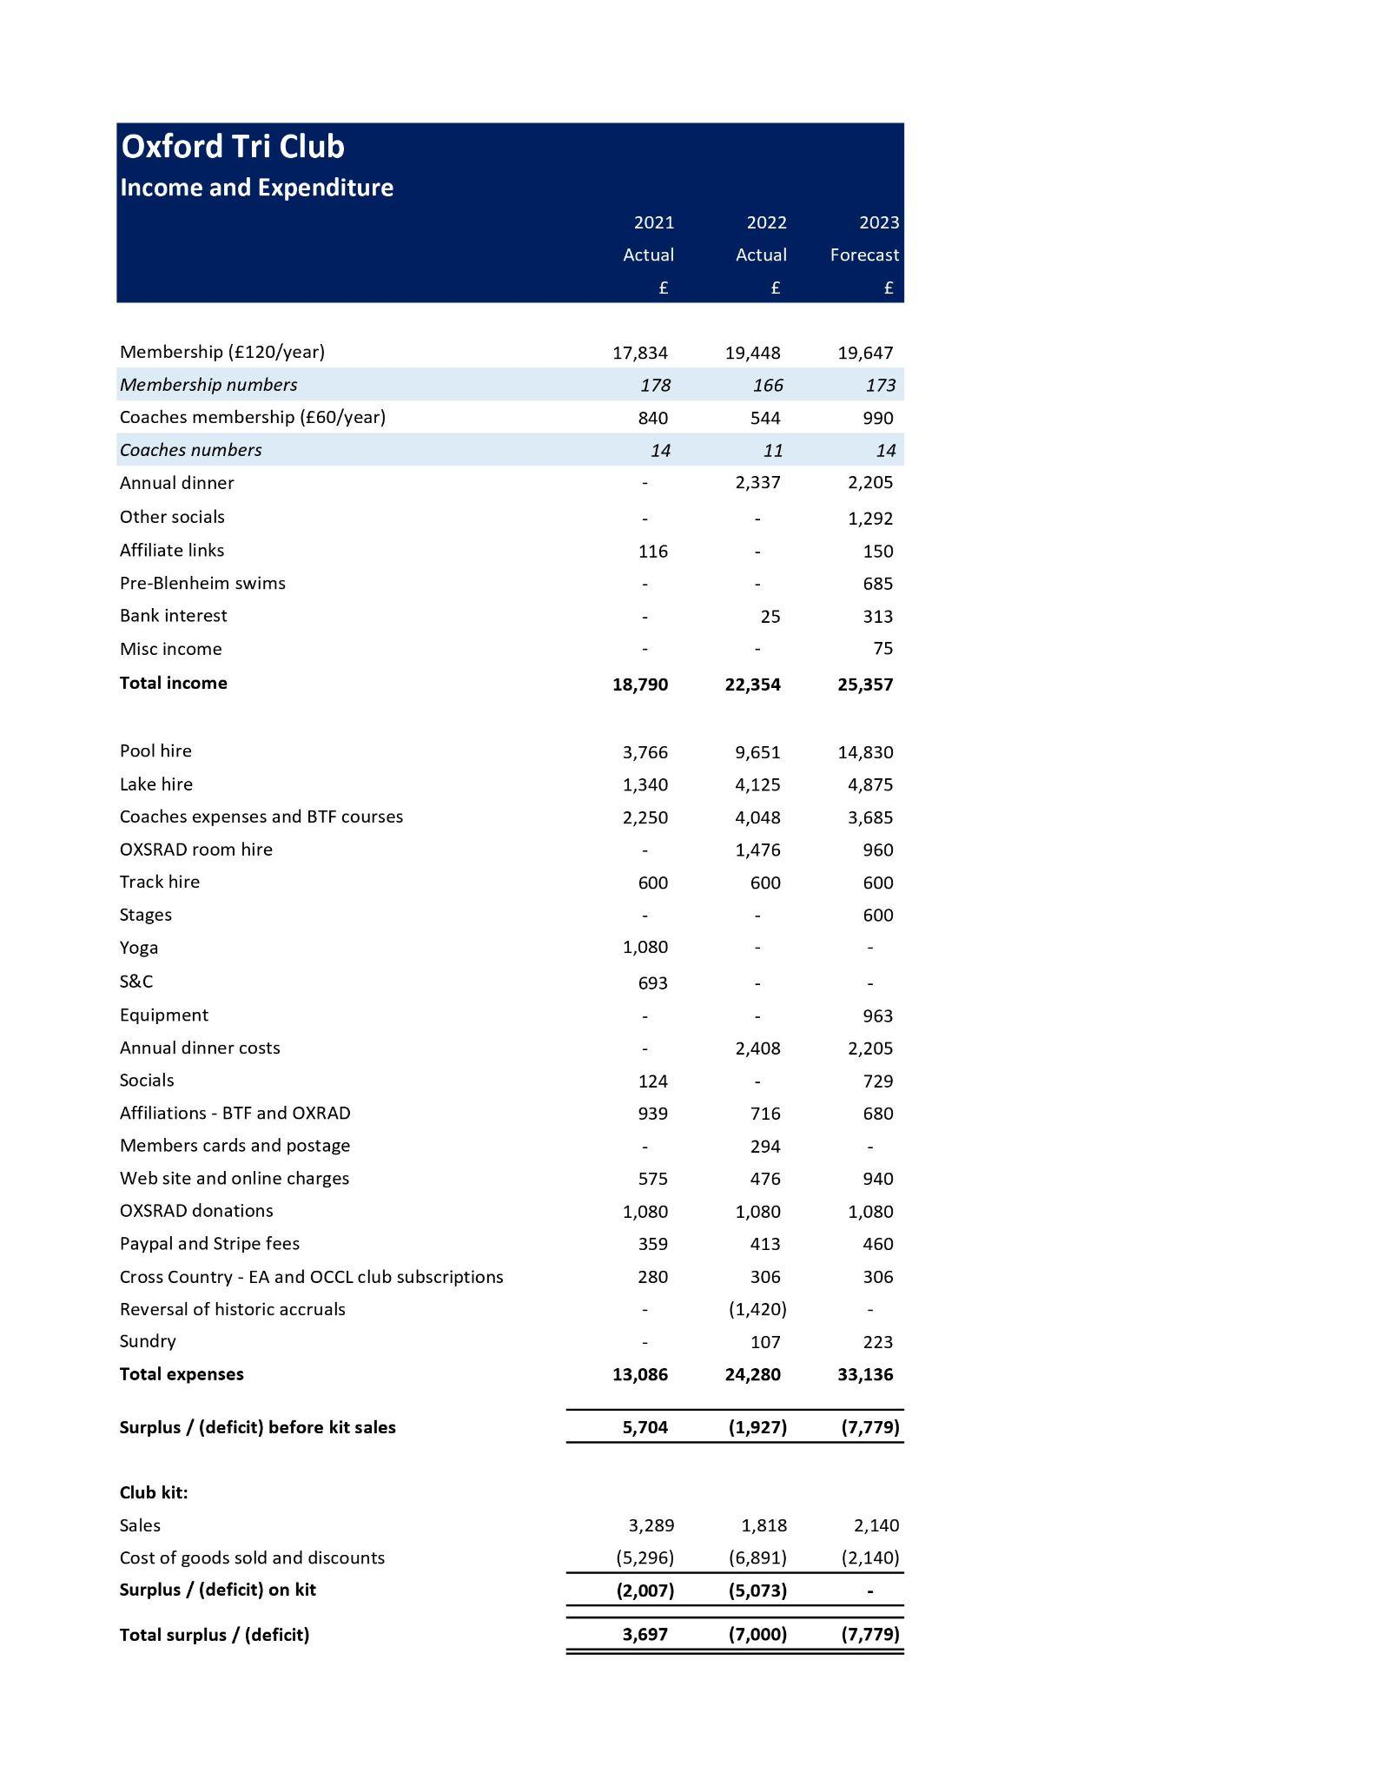
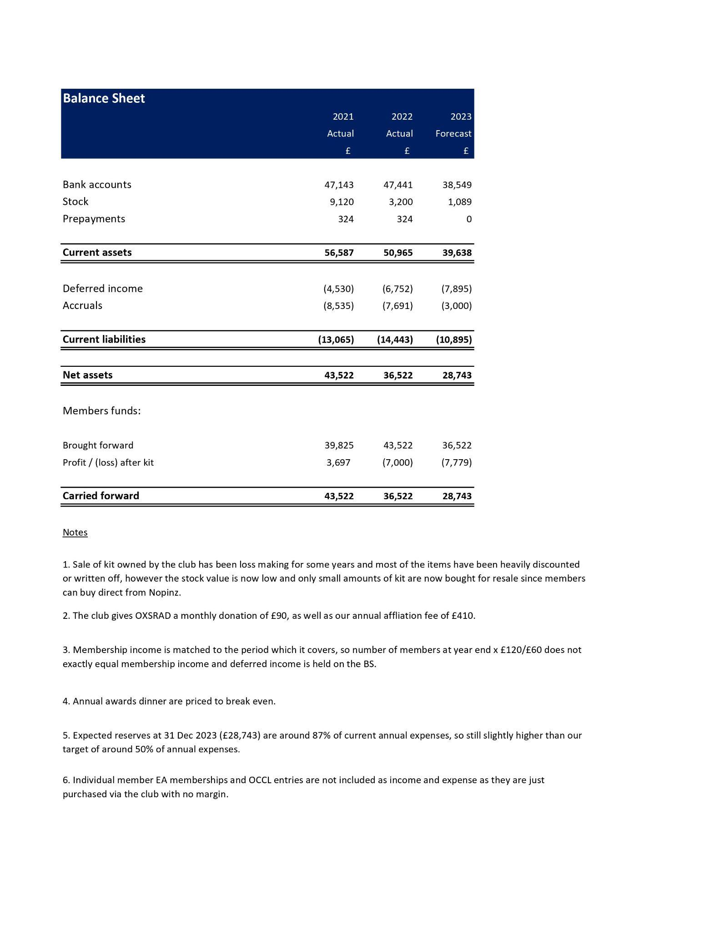

Lead Coach (Nathan):

- Lead coach since 2016 - Alain 2019 and end of 2020 Nathan took the place again
- Club is in a good place and good committee
- Nathan to stand down end of 2023 - needs new blood
- Great self sustaining coaching team
- Thank you to each of the coaches - each named
- Nathan being working with coaches and venues for all sessions to be running swiftly
- 30 sessions a month, 300 coaches sessions for 1 year - 16 coaches
- Need a few more coaches but limited coaching courses available (BTF) - now sessions are opening up - will be drive to get more coaches - OTC to provide financial support
- Need to keep the coaches numbers up to keep running these sessions

Back to Craig:

Thank you to Nathan - brought the club to a good place and have done a lot for the club

Membership Stats:

- 196 total members
- 65%/35% M/F
- Based around and close to Oxford - majority in Oxford
- Year changes from 2020 to 2023 - table
- Increase in memberships 15%
- Look into renewals - very manual - see if we can find a better system to pull out stats

Suggestion to help improve finances - boost membership

Constitution Changes:

Unanimous vote to approve the new constitution.

Election of committee for 2024 - No competing nominations were received so those nominated were elected without contest.

Chair - Craig

Vice Chair/Secretary - Zara

Treasurer - Eleanor

Lead Coach - Sean

Website Lead - Lee

XC Coordinator - Kelly

Membership Secretary - Liz M

Club Captain - Jack and Jane

Welfare Lead - Jane C

Social Lead - Gracee

Kit Lead - Gracee/Liam

Marketing and PR Lead - TBC

GCM - Leftaris, Liam, Stuart, Paul,
Nathan, Liz M, Grace and Jane (6-8 people)

AOB

Thank you from Craig and close the meeting

Please share ideas to committee

