Oxford Tri - 30th May – V3 Routes – Final
Take care; all routes have multiple trips and slips obstacles.
Sections where walking may be needed are shown in orange.
All routes start in the field on a bridleway approximately 300 yards south of The Maybush.
It’s not a fast run, so take your time and enjoy the route. Close the gates & avoid the crops.
Choose your route and pick your start time so that you finish between 12:00 and 12:30
5km | 10km | 15km
All routes start in the field on a bridleway approximately 300 yds south of The Maybush.
Run diagonally across the first field, then keep the hedge on the right until reaching the farm track.
Go more or less straight on following the Bridleway | Take a left and follow the farm track up the slope
Cross the field, over the ditch & on until the tarmac | At top of the slope, keep the farm on the right, and immediately after the farm, turn right along the footpath
Straight on tarmac for 25m then right on footpath up the hill signed for River Thames. | Keep running straight on, through Longworth Village (there is a footpath) until the T junction. Turn right onto Church Lane.
Crest the hill, then after ~40m take the ‘beaten path’ through the hedge on the right. | Follow Bridleway through wrought iron gates,  passing Longworth Manor, then straight on,  until you reach the tarmac road corner in Hinton Waldrist.
Follow the ‘beaten path’ until turning left to cross the original Footpath. | Turn right on the downhill concrete track (This is an unsigned permissive footpath). | Keep straight on, along the tarmac until the Church.
Step over the fence-pole opposite, turn right and follow the hedge downhill. | Follow the track down until it becomes grassy and then peters out. | Turn right and follow the tarmac down the hill and round the left-hand bend.
At the end of the hedge, turn right and re-join the original footpath | Then aim across the field for the Bridge at about 10 o’clock. | Follow the tarmac, then straight on along the farm track and across the field.
 |  | At the hedge, go right, left through the hedge, then right; leading to a bridleway running westwards.
 |  | After 200m, take footpath on the right and take care along the path to TenFoot Bridge.
 |  | Cross bridge, turn right and follow the Thames Path to the next Bridge.
 |  | Cross the bridge and then take a left onto Thames Path.
At end of field, swing to the right, keeping hedge on left.  (Ignore track down to river). | Turn Right and follow the River | Cross the next bridge and then turn left onto Thames Path.
When you cross a bridge into the trees, after 1 (one) metre,
take the ‘goat track’ immediately on the right.
Mind the cable at bottom & take care at the top.
 | Turn left and keep the trees on your left.
Take care through the next group of trees, then keep straight on until you re-join the riverbank.
Follow the River home to The Maybush
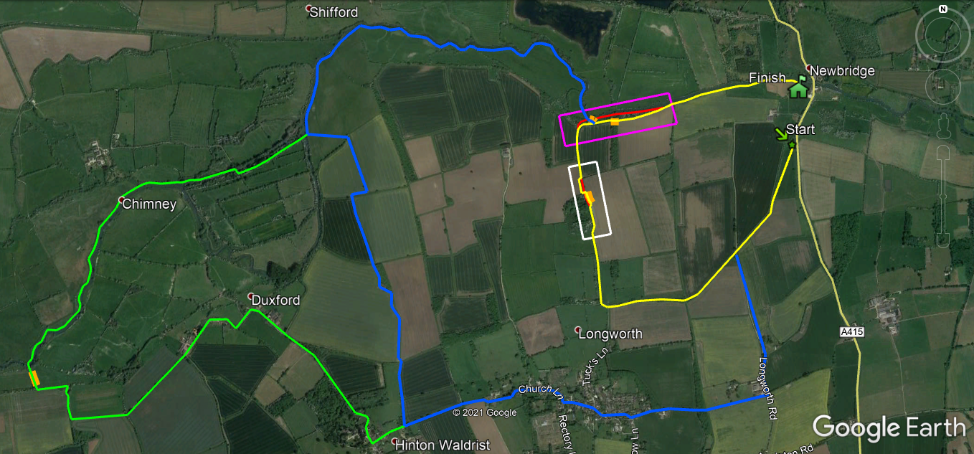
White and Pink Sections shown overleaf.
5km Route; once over the crest of the hill.
At this point the routes wiggle you away from a very slippery downhill section of footpath.
The path in red is advised to be avoided.
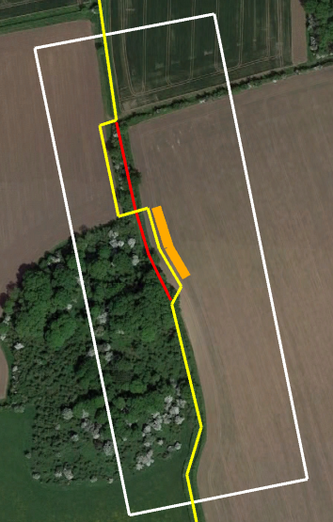

Junction of the 5km and 10 km Routes
At this point the routes guide you away from a slippery & shoe sucking section along the River.
The paths in red are advised to be avoided.
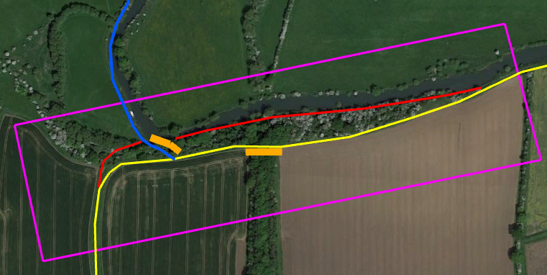
START

